Make sure that you have 4 questions:

|  |  |  |  |  |
| --- | --- | --- | --- | --- |
| Question | Est. Time | Weight | Grade | Notes |
| 1 | 15 min. | 10 points |  |  |
| 2 | 18 min. | 12 points |  |  |
| 3 | 18 min. | 12 points |  |  |
| 4 | 14 min. | 12 points |  |  |
| Neat work |  | 04 points |  |  |

Total Points: 50 points

Total Estimated Time: 65 minutes

Total Time Given: 90 minutes

This test is worth 25% of your final course grade.

This test is an open book. You are allowed to use your notes, PC, Mobile or any other communication devices.

Good Luck!!!!

1. Normalization

Consider the following Table

|  |  |  |  |  |  |  |  |  |  |  |
| --- | --- | --- | --- | --- | --- | --- | --- | --- | --- | --- |
| Student ID | SFName | SLName | Address | City | State | ZipCode | Phone | CourseCode | CName | CGrade |
| 1 | Mary | McCall | 12345 West Road | Houston | TX | 77077 | 281-907-2345,  713-456-9089 | MATH1313 | Algebra I | A |
| 2 | Sam | Romney | 78489 East Road | Dallas | TX | 78909 | 281-999-7856 | HIST1311 | History I | B |
| 3 | Alex | Smith | 23898 NorthEast Road | Houston | TX | 77043 | 281-909-8877,  718-890-3256 | COMP 3321 | Databases | A |
| 4 | Jan | Adams | 11467 West Road | Houston | TX | 77077 | 713-879-3454 | MATH 1314 | Calculus I | B |
| 5 | Sarah | Pieters | 1257 South Road | Dallas | TX | 78901 | 281-909-1122 | COMP 3321 | Databases | C |
| 6 | Marco | DeLion | 2323 SouthWest Road | Houston | TX | 77082 | 713-906-4578 | COMP 2231 | Data Structures | A |
| 7 | Jane | Abrahams | 10110 North Road | Austin | TX | 76098 | 346-832-6745 | HIST1311 | History I | D |

Student ( StudentID, SFName, SLNAME, Address, City, State, ZipCode, Phone, CourseCode, CName, CGrade)

1. Is the table in 1NF? If not, how to put it in 1NF.

No it is not, there are multivalues on phone.

|  |  |  |  |  |  |  |  |  |  |  |
| --- | --- | --- | --- | --- | --- | --- | --- | --- | --- | --- |
| Student ID | SFName | SLName | Address | City | State | ZipCode | Phone | CourseCode | CName | CGrade |
| 1 | Mary | McCall | 12345 West Road | Houston | TX | 77077 | 281-907-2345, | MATH1313 | Algebra I | A |
| 2 | Mary | McCall | 12345 WestRoad | Houston | TX | 77077 | 713-456-9089 | MATH1313 | Algebra | A |
| 3 | Sam | Romney | 78489 East Road | Dallas | TX | 78909 | 281-999-7856 | HIST1311 | History I | B |
| 4 | Alex | Smith | 23898 NorthEast Road | Houston | TX | 77043 | 281-909-8877 | COMP 3321 | Databases | A |
| 5 | Alex | Smith | 23898 NorthEastRoad | Houston | Tx | 77043 | 718-890-3256 | COMP 3321 | Database | A |
| 6 | Jan | Adams | 11467 West Road | Houston | TX | 77077 | 713-879-3454 | MATH 1314 | Calculus I | B |
| 7 | Sarah | Pieters | 1257 South Road | Dallas | TX | 78901 | 281-909-1122 | COMP 3321 | Databases | C |
| 8 | Marco | DeLion | 2323 SouthWest Road | Houston | TX | 77082 | 713-906-4578 | COMP 2231 | Data Structures | A |
| 9 | Jane | Abrahams | 10110 North Road | Austin | TX | 76098 | 346-832-6745 | HIST1311 | History I | D |

1. Based on your answer in part 1 ,Is the table in 2NF? If not, how to put it in 1NF.

No its not, we have to group the <StudentInformation>, <CourseInformation> because they are mentioned multiple times.

Student_Info

|  |  |  |  |  |  |  |  |  |
| --- | --- | --- | --- | --- | --- | --- | --- | --- |
| StudentID | SFName | SLName | address | city | state | zip | Phone | PHone |
|  |  |  |  |  |  |  |  |  |

Course_Info

|  |  |  |
| --- | --- | --- |
| CourseCode | CName | Cgrade |
|  |  |  |

1. Based on your answer in part 2 ,Is the table in 3NF? If not, how to put it in 3NF.

No, its not

Well for this table to be in 3nf non-prime keys should be removed. Which in this case SFName, SLName, Phone Can be the primary keys. We can create another table for course info with CourseCode Cname and CGrage.

|  |  |  |  |
| --- | --- | --- | --- |
| coursecode | CourseCode | CName | Cgrade |

1. Based on your answer in part 2 ,Is the table in BCNF? If not, how to put it in BCNF.

Both tables are determinant. Its is BCNF

1. SQL - Single Table

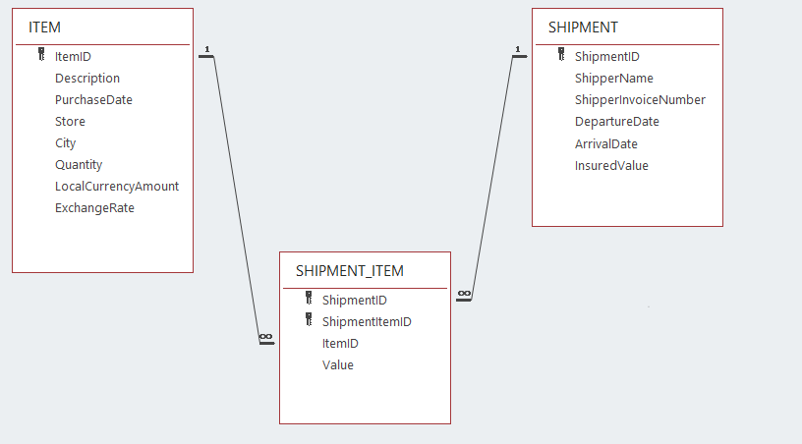

1. List the ShipmentID, ShipperName, and ShipperInvoiceNumber for all shipments that have an insured value greater than $10,000.00.

**Select ShipmentID, ShipperName, ShipperInvoiceNumber**

**From SHIPMENT_ITEM, SHIPMENT**

**Where Value>10000**

1. List the ShipmentID, ShipperName, and ShipperInvoiceNumber of all shippers whose name starts with “AB”.

**Select ShipmentID, ShipperName, ShipperInvoiceNumber**

**Frome SHIPMENT_ITEM, SHIPMENT**

**Where ShipperName LIKE ‘AB%’**

1. Determine the maximum, average and minimum InsuredValue.

**Select Max(InsuredValue)**

**From SHIPMENT**

**Select Avg(InsuredValue)**

**From SHIPMENT**

**Select Min(InsuredValue)**

**From SHIPMENT**

1. Show ItemID, Description, Store, and a calculated column named USCurrencyAmount that is equal to LocalCurrencyAmount times the ExchangeRate for all rows of ITEM.

**Select ItemID, Description, Store, LocalCurrencyAmount* ExchangeRate as USCurrencyAmount**

**From ITEM**

1. Group item purchases by City and Store.

**Select ItemID, City, Store**

**From ITEM**

**Group By City, Store**

1. Count the number of purchases having each combination of City and Store.

**SelectCount(City, Store)**

**From ITEM**

**Where City(+)=Store**

1. SQL - Multiple Table



1. Show the ShipperName, ShipmentID, and DepartureDate of the shipments for items that were purchased in Singapore. Use a subquery. Present results sorted by ShipperName in ascending order and then DepartureDate in descending order.

**Select ShipperName, ShpmentID, DepartureDate**

**From SHIPMENT**

**Where ItemID in**

**(Select City, ItemID**

**From ITEM**

**City=’Singapore’)**

**Order By ShipperName, DepartureDate DESC;**

1. Show the ShipperName, ShipmentID, and DepartureDate of all shipments that have an item that was purchased in Singapore. Use a join, but do not use JOIN ON syntax. Present results sorted by ShipperName in ascending order and then DepartureDate in descending order.

**Select ShipperName, ShipmentID, DepartureDate**

**From SHIPMENT**

**Where SHIPMENT.ShipmentID= ITEM.ItemID**

**And ITEM.City=’Singapore’**

**Order By ShipperName, DepartureDate DESC;**

1. Show the ShipperName, ShipmentID, and DepartureDate of all shipments that have an item that was purchased in Singapore. Use a join using JOIN ON syntax. Present results sorted by ShipperName in ascending order and then DepartureDate in descending order.

**Select SHIPMENT.ShipperName, SHIPMENT.ShipmentID, SHIPMENT.DepartureDate**

**From SHIPMENT, ITEM**

**Join ITEM On ITEM.ItemID=SHIPMENT.ShipmentID**

**Where ITEM.City LIKE ‘Singapore’**

**Order By ShipperName, DepartureName DESC;**

1. SQL - Joins

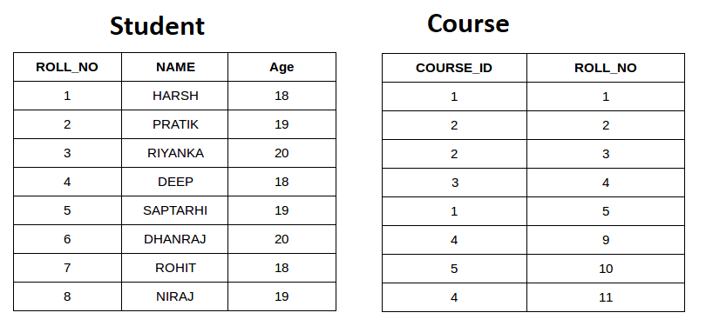

SELECT *

FROM STUDENT INNER JOIN COURSE ON

Student.ROLL_NO = Course.ROLL_NO;

Inner Join

|  |  |  |  |  |  |  |  |  |  |
| --- | --- | --- | --- | --- | --- | --- | --- | --- | --- |
| ROLL_NO | NAME | AGE | COUSE_ID | ROLL_NO |  |  |  |  |  |
| 1 | HARSH | 18 | 1 | 1 |  |  |  |  |  |
| 2 | PRATIK | 19 | 2 | 2 |  |  |  |  |  |
| 3 | RIYANKA | 20 | 2 | 3 |  |  |  |  |  |
| 4 | DEEP | 18 | 3 | 4 |  |  |  |  |  |
| 5 | SAPTARHI | 19 | 1 | 5 |  |  |  |  |  |
|  |  |  |  |  |  |  |  |  |  |
|  |  |  |  |  |  |  |  |  |  |
|  |  |  |  |  |  |  |  |  |  |
|  |  |  |  |  |  |  |  |  |  |
|  |  |  |  |  |  |  |  |  |  |
|  |  |  |  |  |  |  |  |  |  |

SELECT *

FROM STUDENT LEFT JOIN COURSE ON

Student.ROLL_NO = Course.ROLL_NO;

Left Outer Join

|  |  |  |  |  |  |  |  |  |  |
| --- | --- | --- | --- | --- | --- | --- | --- | --- | --- |
| ROLL_NO | NAME | AGE | COUSE_ID | ROLL_NO |  |  |  |  |  |
| 1 | HARSH | 18 | 1 | 1 |  |  |  |  |  |
| 2 | PRATIK | 19 | 2 | 2 |  |  |  |  |  |
| 3 | RIYANKA | 20 | 2 | 3 |  |  |  |  |  |
| 4 | DEEP | 18 | 3 | 4 |  |  |  |  |  |
| 5 | SAPTARDHI | 19 | 1 | 5 |  |  |  |  |  |
| 6 | DHANRAJ | 20 | NULL | NULL |  |  |  |  |  |
| 7 | ROHIT | 18 | NULL | NULL |  |  |  |  |  |
| 8 | NIRAJ | 19 | NULL | NULL |  |  |  |  |  |
|  |  |  |  |  |  |  |  |  |  |
|  |  |  |  |  |  |  |  |  |  |
|  |  |  |  |  |  |  |  |  |  |

SELECT *

FROM STUDENT RIGHT JOIN COURSE ON

Student.ROLL_NO = Course.ROLL_NO;

Right Outer Join

|  |  |  |  |  |  |  |  |  |  |
| --- | --- | --- | --- | --- | --- | --- | --- | --- | --- |
| ROLL_NO | NAME | AGE | COUSE_ID | ROLL_NO |  |  |  |  |  |
| 1 | HARSH | 18 | 1 | 1 |  |  |  |  |  |
| 2 | PRATIK | 19 | 2 | 2 |  |  |  |  |  |
| 3 | RIYANKA | 20 | 2 | 3 |  |  |  |  |  |
| 4 | DEEP | 18 | 3 | 4 |  |  |  |  |  |
| 5 | SAPTARHI | 19 | 1 | 5 |  |  |  |  |  |
| NULL | NULL | NULL | 4 | 9 |  |  |  |  |  |
| NULL | NULL | NULL | 5 | 10 |  |  |  |  |  |
| NULL | NULL | NIULL | 4 | 11 |  |  |  |  |  |
|  |  |  |  |  |  |  |  |  |  |
|  |  |  |  |  |  |  |  |  |  |
|  |  |  |  |  |  |  |  |  |  |
|  |  |  |  |  |  |  |  |  |  |